David Wan

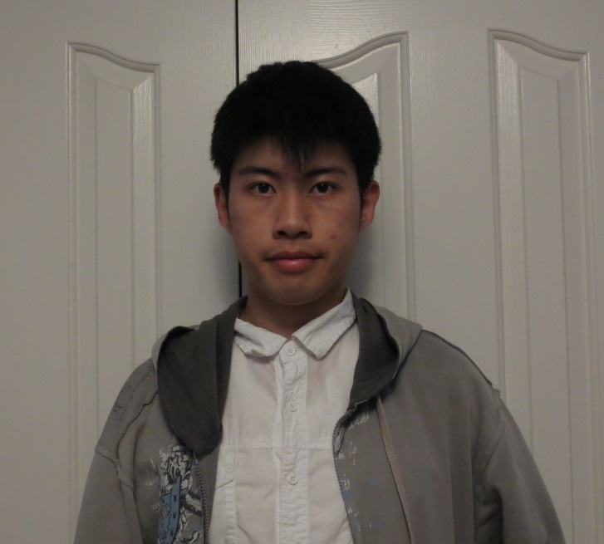

David Wan is a third year Computer Science specialist student at the University of Toronto. His goal is to become deeply entrenched in the world of video game programming and design. Developing memorable and enjoyable video games for millions to enjoy and making his mark on pop culture is what David is all about. He spends numerous hours of his days with Unreal Engine 4, a powerful game engine that is utilized by indie game developers and triple-A game studios alike. In fact, Unreal Engine is the backbone of his own game dubbed ‘Project Artemis’. And when he’s not busy hammering away in Unreal Engine, he’s constantly challenging himself and pushing the boundaries of his own abilities. Whether it be hackathons or self-given programming challenges, David is always looking for ways to optimize his performance in game programming and design.